Provincial Policy and the Digital Divide
Recommendations from the BC³ conference in Prince George

August 8, 2003

The BC³

Representing over 45 community and large regional networks that span the majority of the Province, from Atlin to the Kootenays, from the Peace to Vancouver Island and the Central Coast, the Broadband Community Champions Consortium (The BC³) is a key stakeholder in the Provincial deliberations regarding the Digital Divide.

BC³ members represent the vast majority of the communities that the Province deems as “unserved” as well as a large number of the currently “served” communities that have existing community networks.

The Position of the BC³

The BC³ recommends the following for the Province’s consideration:

- General Approach

That the Province utilize its full aggregate network spending to help leverage significantly improved connectivity to every community in BC and;

That this network spending should be aggregated based on the broadest definition of a Provincial entity as possible (Eg: health regions, BC Hydro etc…) and;

That in developing a strategy to leverage improved connectivity to communities the Province should work closely with the BC³ and its members as:
  - They represent the telecommunications interests of local leaders from multiple sectors including: business, health, education, and social organizations within the unserved communities of BC.
  - These champions have, through significant education and consultation campaigns, created the cross-sectoral awareness and community buy-in required for local investment in broadband infrastructure.
  - They will have access to considerable financial resources. The champions, as representatives of their local initiatives, will have access to federal funding through BRAND, the Strategic Infrastructure Fund, and the Softwood Industry Community Economic Adjustment Initiative (SICEAI) as well as significant local funding through Tribal, Municipal and Regional sources.
  - There is no one-size-fits-all solution to the divide. The most effective manner in which to bridge the divide is to ensure that the local stakeholders are empowered to deliver the solutions most appropriate for their communities and regions. This is best achieved through ongoing consultation with the local community champions on a community-by-community basis.

In essence, in order to ensure a successful, sustainable solution to the digital divide the Province and the BC³ need to coordinate their efforts:
- The Province has the financial leverage and political power to ensure connectivity gets driven out to each community’s doorstep but does not have the financial or human resource capacity to bridge the last-mile.
- The members of the BC³ have the local knowledge, commitment, support and financial wherewithal necessary to ensure that their residents, businesses and organizations get access to affordable broadband and the knowledge to use it to their benefit. They do not, however, have the capacity to build the electronic highway out to each region.

- Tendering

That the Province should tender separately for:

  - IX (Inter-Exchange) circuits. These are the circuits that take network traffic between communities. These should be tendered on a regional basis. These regional tenders should have, as part of their evaluation criteria, a requirement that the bidder demonstrate leverage of the contract to further regional economic and social development goals.
  - Local circuits. These are the circuits from the local Point of Presence (PoP) to the school, hospital, etc… There should be one tender process for each community that comprises all the local government business within that community. These local tenders should have, as part of their evaluation criteria, a requirement that the bidder demonstrate leverage of the contract to further local economic and social development goals.

- Network Management

The BC³ recommends that, should the Province choose to outsource network management, the Network Manager should be excluded from bidding to supply any IX or local circuits.

This manager should be responsible for the creation and management of an Open Access PoP in every community.

- Open Access PoPs

Open PoPs should operate under the following policy directives:
- Published “Postage Stamp” prices Province-wide. Prices for each 1Mbps of symmetrical transport to Vancouver or to any other location within the province should be the same at every PoP.
- The network manager should be incented to reduce these prices over time
- A connection between any two or more points within the Province should NOT incur a bandwidth usage fee or a distance charge. This would enable any Service Provider anywhere to get bandwidth at a flat rate to the Vancouver (or Prince George or Kamloops) Internet Exchange and then purchase Internet bandwidth in the most competitive markets in the province. An example of this is the Alberta Supernet project, which has a flat $50 per Mbps fee for connectivity and transport within the Province.

- Policy Development and Contract Management

That:
As a great deal of the capital required to bridge the divide will be coming from the communities, and;

As the community champions represent the telecommunications interests of key local stakeholders within the communities, and;

As the service levels the communities receive from the IX circuits will have a significant impact on the ability of the communities to serve the needs of their residents, businesses and institutions and meet the social and economic goals of the community

the community networks should have representation on any policy setting/ oversight body that is created as part of the solution to the digital divide

- General Policy

- The residents, businesses and community organizations that the BC³ represents want choice. In simple terms this means that they want the ability to choose and change their voice, video and data providers. Providing customers with choice means finding ways to encourage competition at the service level. The BC³ believes this must be an essential policy goal of any forthcoming initiative.

Diagram demonstrating the recommended model:

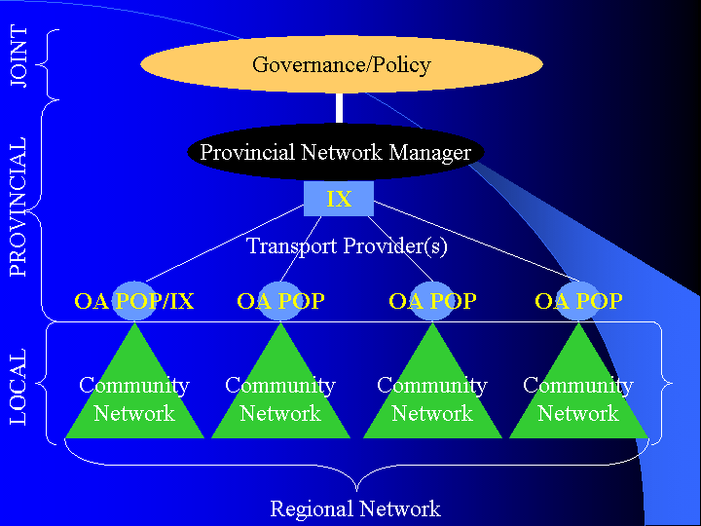
Agreed to on this date by:
First Name | Last Name | Organization | Community | Initiative | Email | Phone
John | Savage | Gold Trail Open Network | Ashcroft and the entire Gold Country region | www.gtnet.ca | jsavage@sd74.bc.ca | 250-453-9211
Fran | Newall | Atlin Community Network www.atlin.net | Atlin | Atlin Net | admin@atlin.net | 250-651-7711
Linda | Myres | BCSA/bamfieldcommunity.com | Bamfield | CAP Champion/Clayoquot Mamook Development BRAND project | lmyres@bamfield.ca | 250-728-1220
Keith | Hamilton | Heiltsuk Tribal Council | Bella Bella | Central Coast Broadband Project | khamilton@bellabella.net | 250-957-2556
Karen | Laine | Bella Coola Valley Learning Society | Bella Coola | Central Coast Broadband/Coast Connect Development Society | bcv_ls@yahoo.ca | 250-799-5811
Crystal | Kimber | Bridging the Canyon | Boston Bar/North Bend | Building Bridges in a Learning Society | kimcry@uniserve.com | 604-867-9094
John | Kerr | Tatlayoko Think Tank Ltd. www.chilcotin.bc.ca/ttt | Cariboo - Chilcotin Region | Cariboo Chilcotin Broadband Network | ttt@coyote.chilcotin.bc.ca | 250-476-1187
Lisa | Shaver | Penelakut Tribe | Chemainus | BC Community Champions | Shaver@uniserve.com | 250-246-2321
Frank | Mayhood | City of Kamloops | City of Kamloops | Kamloops Community Network | itmgr@kamloops.ca | 250-828-FIBR
Matt | Wenger | CMON | The Columbia Basin Region | CMON | mwenger@cbt.org | 250-365-9589
Stan | Boychuk | Clayoquot Biosphere Trust | Communities within Clayoquot/Barkley Sounds | Clayoquot Sound – Mamook Broadband Project | Stan.boychuk@clayoquotbiosphere.org | 250-726-4715
Michel | Labelle | City of Coquitlam http://www.coquitlam.ca | Coquitlam | Intelligent Transportation System/Community Fibre | mlabelle@coquitlam.ca | 604-927-3620
Sharon | Bennett | Communityfutures-strathcona.com | Courtenay/Campbell River | Strathcona Broadband Initiative BRAND phase one round 2 | Sharon.bennett@crcn.net | 250-334-2427 ext 228
Don | Maki | Ktunaxa Kinbasket Tribal Council www.kktc.bc.ca | East Kootenay Region | BRAND: Ktunaxa Kinbasket Community Network | dmaki@kktc.bc.ca | 250-489-2464
Renee | Bernier | Community Futures Dev Corp of Boundary Area | Grand Forks | BRAND | renee@boundarycf.com | 250-442-2722 250-442-8766
Bill | McQuarrie | Interior Science Innovation Council www.isic.ca | Kamloops-Thompson Nicola Region | Thompson Nicola Broadband Network | bmcquarrie@isic.ca | 250-828-1713
Hans | DeBruyn | Okanagan Technology Consulting Inc. www.okanagantechnology.com | Lower Similkameen Region | Similkameen Valley Broadband Project | hans@okanagantechnology.com | 250-766-1818
Chief Fred | Sampson | Siska Band | Lytton |  | siska@direcway.com | 250-455-2219
Tom | Aird | Saulteau First Nations | Moberly Lake | Treaty 8 Initiative | Saulteau@telus.net | 250-788-3955
Royce | Schmidt | Village of Montrose www.village.montrose.bc.ca | Montrose | Beaver Valley BRAND Working Group | Royce@glacierwind.com | 250 367 9490
Charles | Peters | Lower Stl'atl'imx Tribal Council | Mount Currie | BRAND | cjjpeters@telus.net | 604-894-0021
Alistair | Skey | School District No. 10 | Nakusp | CMON | askey@sd10.bc.ca | 250-265-3638 ex 26
Gary | Patsey | Nisga'a Lisims Government www.nisgaalisims.ca | New Aiyansh | Nisga’a Lisims Broadband Project | Gary.patsey@nisgaa.net | 1 866 633 0888
Gabe | Williams | Lower Stl'atl'imx Tribal Council | Pemberton | LSTC Broadband | tselxasqet@yahoo.com | 604-894-0021
Ron | Shongrunden | School District 67 www.SD67.BC.CA | Penticton Summerland | Okanagan Skaha Network | rs@summer.com | 250-770-7705
Evelyn | Clark | Community Futures Dev Corp Mt. Waddington www.island.net/~futures/ | Port McNeill and the North Island communities | Northern Vancouver Island Broadband Initiative | evelyn@island.net | 250-956-2220
Bev | Collins | Powell River Community Network www.prreds.prcn.org | Powell River | Powell River Broadband Company | bev@prcn.org | 604-485-0041
Stephane | Labonne | City of Prince George www.city.pg.bc.ca | Prince George | PGTX and PG Community Fibre Network | slabonne@city.pg.bc.ca | 250-561-7655
Larry | Deacon-Rogers | Community Futures Dev Corp of Pacific NW | Prince Rupert | Broadband Service to the Pac NW Region of BC | RAIN@cfdc-pnw.com | 250-622-2352
Tamara | Smith | Slocan Valley Economic Development Commission | Slocan Valley Region |  | Tamarasmith@look.ca | 250.226.0097
Les | Deacon-Rogers | Onewayout.net Society | Stewart | Broadband Service to Stewart | deaconrogers@mountainharbour.ca | 250-636-2380
Vincent | Joseph |  | Tachie
Arvo | Koppel | Peace Region Internet Society (www.pris.ca) | The Peace River Region | www.pris.ca | pris@pris.ca | 250-782-5128
Deborah | Page | Tl'azt'en Nation Education | Tl'azt'en Nation |  | tlazteneducation@direcway.com | (w)250-648-3227 (h) 996-5013
Lonnie | Nunweiler | www.valemount.org | Valemount | Canoe-Robson Valley Broadband Network | lonnie@valemount.com | 250-566-4199 566-4698
Steven | Chan | www.vcn.bc.ca | Vancouver | Vancouver Community Net | schan@vcn.bc.ca | 604 408 9483
Dan | Carberry | Community Futures Stuart Nechako onramp.hwy16.com/~cfdcsn/ | The Highway 16 communities (NW Region) | BC NW Broadband Committee BCNBC | cfdcsn@telus.net | 250-567-5219
Gareth | Shearman | Vancouver Island Open Network victoria.tc.ca/vion | South Island and the Gulf Islands | South Island Open Networks | shearman@victoria.tc.ca | 250-479-2851
Phillip | Djwa | First Nations SchoolNet www.fnesc.ca | First Nations SchoolNet | First Nations SchoolNet | phillip@fnesc.ca | 604-925-6087
Elaine | Bottineau | West Moberly First Nations | West Moberly |  | ebottineau@westmo.org | 250-788-3663
Grand Chief Edward | John | First Nations Summit www.fns.bc.ca |  | First Nations Technology Council | cbraker@fns.bc.ca | (604) 990-9939

